Introduction
In this assignment, our task is to find various ways that AR could be employed with the aim of improving experiences in museums. Therefore, we conducted field research to examine how museum users currently use the museums and the experiences they have regarding these exhibits. To conduct field research, there are two museums that my friend visited. The two museums are the Royal Air Force Museum and the Horniman museum. My friend is a lover of the museum, and therefore we joined hands to accomplish the research task. However, I cannot use my own experience to examine various ways of improving museum experiences using AR. The basis of my improvements will be my friend who visited the museum frequently and their experiences will help me a lot.
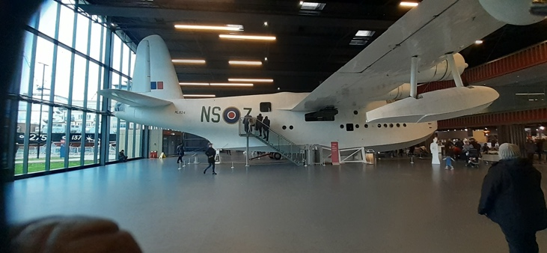
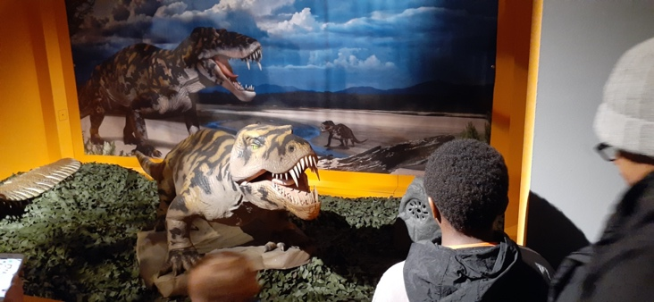
Research
The two museums visited are the Royal Air Force Museum and the Horniman museum. In this field research, we were looking for different approaches that the two museums use in order to display their exhibits. In other words, we were looking at whether the museums display their exhibits traditionally or they use interactive ways to display exhibits which make them more interesting. There is various information that we collected regarding the two museums. The Royal Air Force Museum (RAFM) had employed an interactive way of displaying their exhibits. “However, many of their exhibits still had the traditional information board attached to them which never attracted my friends.” (In Dieck & In Jung, 2019) RAFM has made a huge step in making the museum experience interactive although it is yet to achieve this. On the other hand, the Horniman Museum in displaying their exhibits applies an approach that is more traditional. The use of guide tours is an affirmation of this, and a visitor may opt to explore the museum on their own. Each exhibit at Horniman had an information board that educated the visitors about it. The information collected was analysed based on interaction. Museum exhibits should be highly interactive so that visitors being much engaged which will improve their experiences. There are various discoveries made in these museums. First, the two museums had long queues visitors getting to use the interactive exhibits. The second discovery was a lack of interactivity as the two museums mostly use traditional approaches when displaying their exhibits. The last discovery is the use of text that many of my friends did not seem to be attracted to them. The three discoveries influenced our AR design ideas massively. AR would ensure no long queues as visitors will use their smart devices or rent from the museum and get a whole new experience of the museum exhibits. For interactivity and text usage, the AR will superimpose sounds and text on the devices the visitors are using to view the exhibits to bring a reality altered version.

using to view the exhibits to bring a reality altered version.

Design Concepts
The design concept of the AR is a 3D one with interactive text displayed on the exhibits. This concept is aimed at reducing large queues as visitors will use the AR to view the exhibitions. “This AR concept will enable visitors to use their tablets or smartphones to see the exhibits come alive and be transported to the reality of the 21st-century.” (In Dieck & In Jung, 2019) This design caters to every visitor including the visual impaired as the experience will be made very suitable. The model will be an immersive installation in three-dimensional animations where visitors will interact with. The picture below shows a visitor interacting with the AR concept.

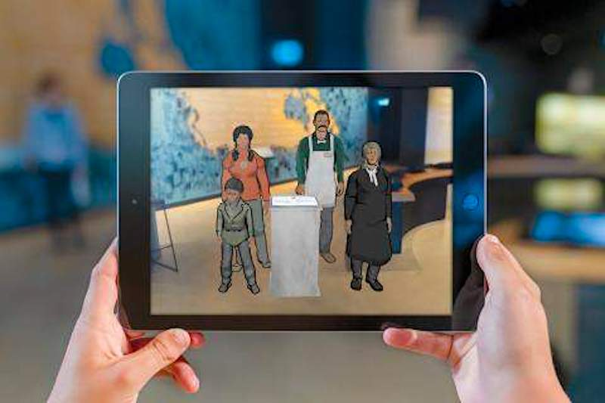
The image below shows an AR design concept transforming an exhibit to the 21st-century exhibit.
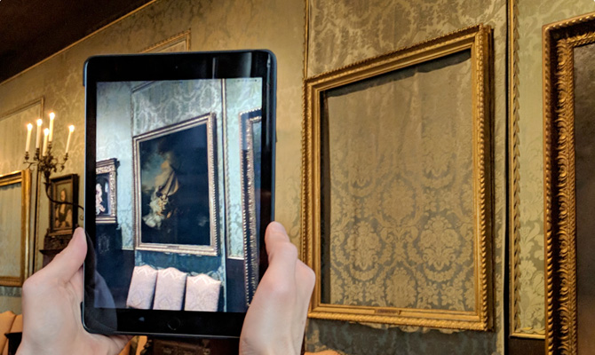

There are different forms of AR that will be used. These are marker-based AR and marker less AR.
Prototype
In order to turn this AR concept into a running prototype, the concept after being developed in an interactive design process was subjected to a testable set up to evaluate both software and hardware. A basic pilot experiment was also conducted in order to explore what it means about the interactivity of the design concept. “The decision made was that the AR design concept needed some modification.” (In Crawford & In Kane, 2017) The modification was to allow visitors to record their experience at the museum which they can enjoy later in the comfort of their homes. The picture below shows a visitor recording a museum experience using the modified AR concept to enjoy later without visiting the museum.

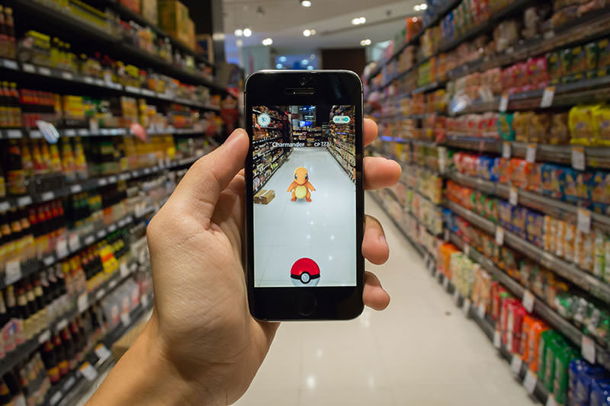

Team working
The team comprised my friend and I where my friend visited the museums. Teamwork was very critical, and work and responsibility were not distributed among team two of us. The team performed work and responsibilities one after the other and thus made us achieve our goal.

Conclusion
AR has great potential in improving the experiences of visitors at a museum. The two museums that visited, the Royal Air Force Museum and the Horniman Museum, basically employed traditional approaches in displaying their exhibits leading to long queue lines, lack of interactivity and unfriendly texts. The use of AR in these museums will solve three issues as it will create an interactive experience the visitors will enjoy as exhibits will come alive and be transported to the reality of the 21st-century. (In Crawford & In Kane, 2017)

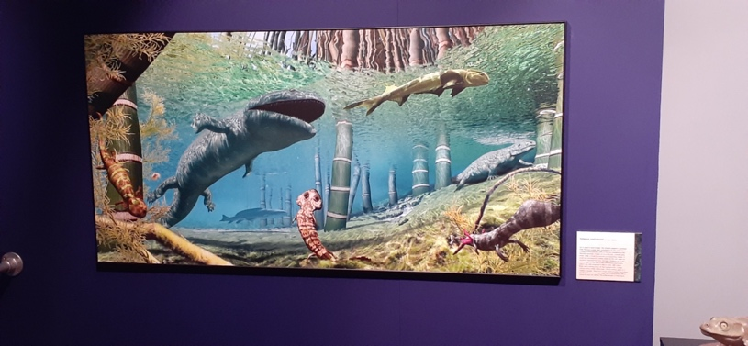

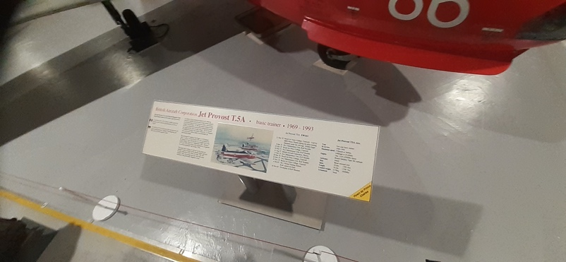

References
In Dieck, M. C., & In Jung, T. (2019). Augmented reality and virtual reality: The power of AR and VR for business.
In Crawford, B. A., & In Kane, E. (2017). The augmented museum: Essays on opportunities and uses of augmented reality in museums

